Geoff Bohling
5 September 2005

Stochastic Simulation

Sequential Gaussian Simulation, Zone A Porosity

We will use sequential Gaussian simulation to generate six realizations of the porosity for Zone A. To start this process, select Sequential Gaussian (sgsim) from the Simulation menu and fill out the Files tab of the Parameters for sgsim dialog box (note that there is an error in this screen shot–the window for Y should contain Y m, not X m!):

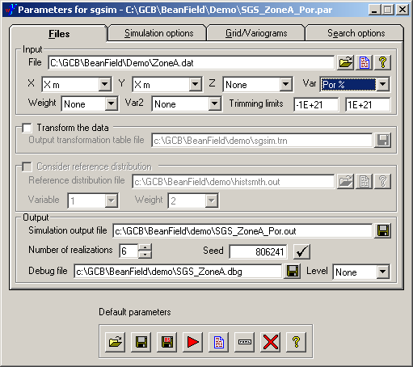

Note that I have turned off the Transform the data option (as I did for kriging) because I am assuming that the porosity values follow a Gaussian (normal) distribution closely enough to begin with. When the underlying data values follow a distinctly non-normal distribution, they should be normal-score transformed prior to simulation (or kriging) using the options provided here, but I will not go into those issues in this exercise. I have selected six realizations just for the sake of a display I intend to generate. Clicking on the check mark next to the Seed text box will generate a different seed for the random number generator used in the simulation process. Using the same seed will result in the same sequence of numbers being generated over again.

On the Simulation options tab, set the Kriging type to Ordinary kriging so that the process estimates a local mean from surrounding data. The Tails interpolation/extrapolation parameters have to do with the backtransformation process that would be performed if we had chosen to transform the data prior to simulation. Since we haven’t, I believe these parameters actually have no influence on the results.

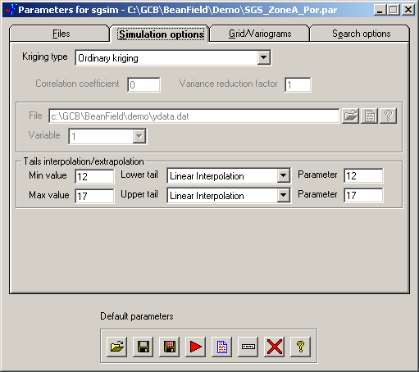

The Grids/Variograms tab should be set as it was for kriging the porosity:

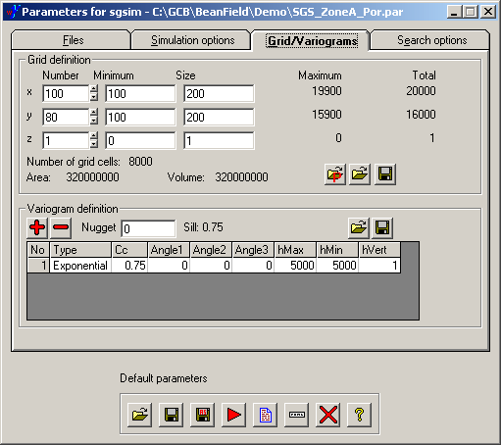

On the Search options tab I have increased the search radii to 5000 m in both directions:

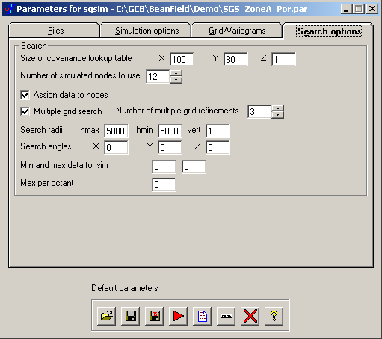

The Assign data to nodes option will relocate the conditioning data at the wells to grid nodes to increase the efficiency of the search process. A side effect of this repositioning is that the conditioning data values will actually be represented in the final grid, although (in general) at a different location from their real-world location. In this exercise all the well coordinates happen to be at cell centers, so zero displacement is required to move them the nearest grid nodes. The Multiple grid search option will first perform the simulation on a fairly coarse grid in order to reproduce larger-scale structures an then fill in with a sequence of finer grids until the grid resolution specified on the Grids/Variograms tab is reached.

Save the parameters in a new file and run the sgsim program by clicking on the red arrow.

The output will be a GSLIB grid file containing the six different simulations, all stacked up on top of each other. The last entry on the second line indicates that the file contains grids for six realizations:

SGSIM Realizations
1 100 80 1 100.00000 100.00000 0.00000000 200.000 200.000 1.00000 6
value
14.655300
14.832422
14.759187
15.218584
15.223752
14.523974
14.423852

You can use pixelplt to view the results one realization at a time, just as you did for the kriging results. You use the Realization number text box to choose which realization to display:

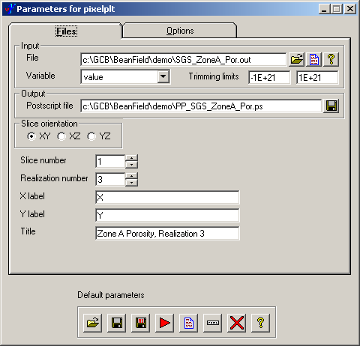

Each realization has considerably more character than the kriged map of porosity:

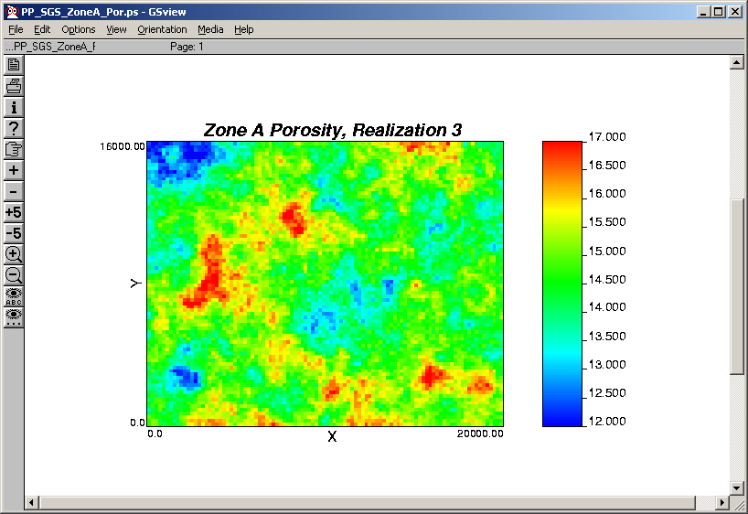

However, no single realization can be taken as a better representation of reality than any other without applying some external criterion such as a ranking based on matches to production history produced by running a set of realizations through a flow simulator.
I have used the R statistical language to produce a gray-scale display of all six simulations together:

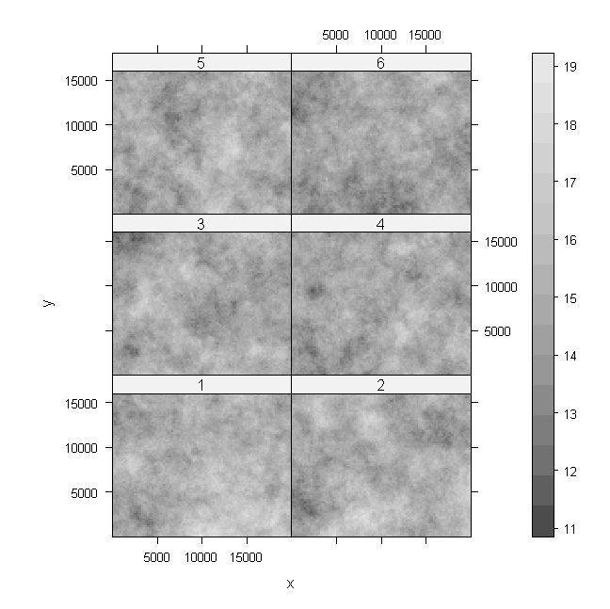

Sequential Gaussian Simulation, Zone A Thickness

The sgsim program does not offer an option for kriging with a trend. Therefore, we will just use ordinary kriging as the Kriging type, hoping that the locally varying mean estimate will be adequate to account for the trend. Again, we will use the model fit to the variogram in the direction N 135° E as representing the trend-free variogram.

Fire up the Parameters for sgsim dialog box, change the variable (Var) to Thk m and change the name of the output file (again, note the erroneous entry in the Y window):

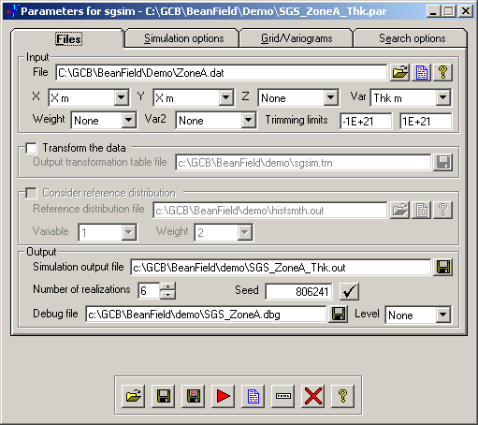

You can leave the Simulation options tab as it was for porosity, with the Kriging type set to Ordinary kriging.

On the Grid/Variograms tab, set the variogram model parameters to those we fit to the N 135° E thickness variogram:

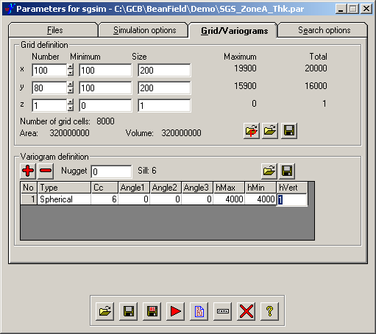

You may leave the search options as they were for porosity simulation. Save the parameters in a new file and run the process to generate six simulations for the zone thickness.

Run the results through pixelplt to examine the different realizations:

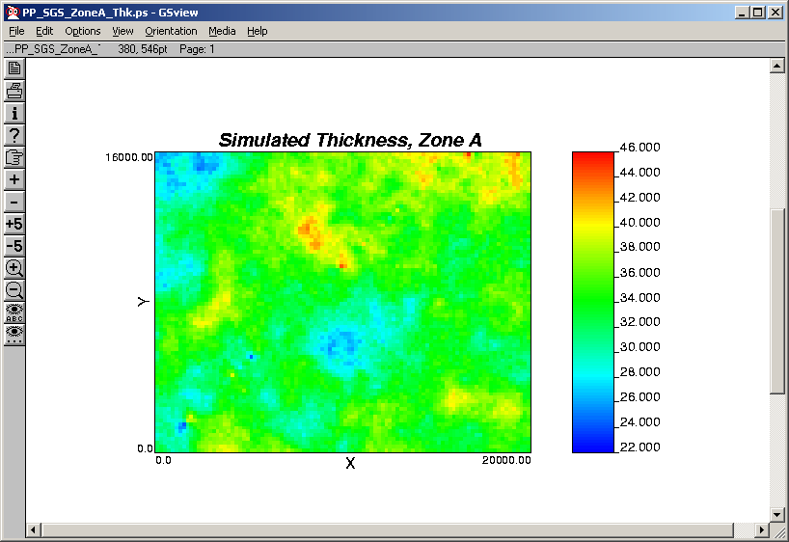

To my eyes, these realizations did not look quite as “trendy” as the data, meaning that the ordinary kriging approach was perhaps not adequate for reproducing the underlying trend.

Sequential Gaussian Simulation, ZoneA LogPerm

Just as we did for the kriging of LogPerm, we would like to perform sequential Gaussian simulation of LogPerm using porosity as a secondary variable. However, as far as I can tell, the sgsim program will not use all six realizations of porosity in the simulation grid file we created early to serve as the gridded secondary variables for six different realizations of LogPerm. Instead, it seems to just read the first realization of the porosity values and uses this for all six realizations of LogPerm. Therefore, I will take a different approach: generate six conditional simulation of the LogPerm residuals in WinGslib, read the simulated residuals and porosities into Excel, generate corresponding grids of LogPerm based on the regression equation, and export these grids for display. Furthermore, sequential simulation using a Gaussian semivariogram can easily lead to unstable results, so I have fit an alternative variogram to the LogPerm residuals, namely a spherical model with a sill of 0.02 and a range of 5200, and will use that for the simulations. Due to the spherical variogram’s steeper rise from the origin, it will produce rougher realizations of the LogPerm residuals than we would get (if we could) from the Gaussian semivariogram.

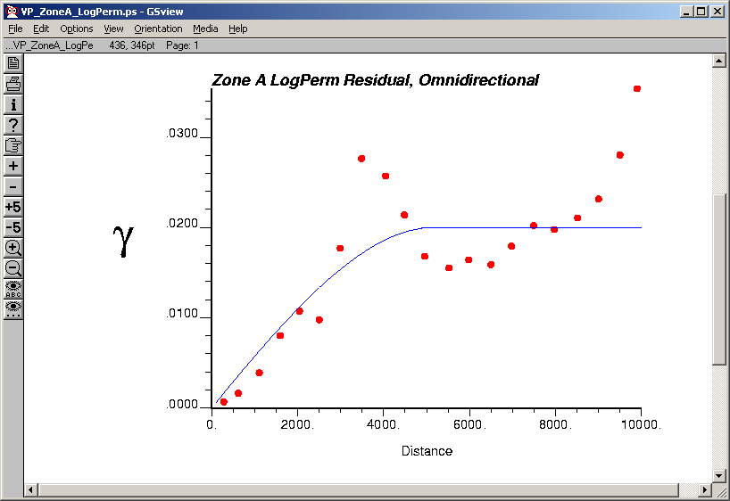

Fire up the Parameters for sgsim dialog box one more time and set things up to model LogPermRsd with no secondary variable. Set the lower trimming limit to exclude the missing values in LogPermRsd. Also, set the number of simulations to 6:

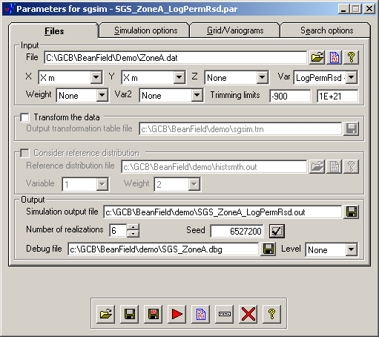

On the Simulation options tab, set the Kriging type to Ordinary kring. Again, the tails parameters don’t matter since we are not transforming or backtransforming the data:

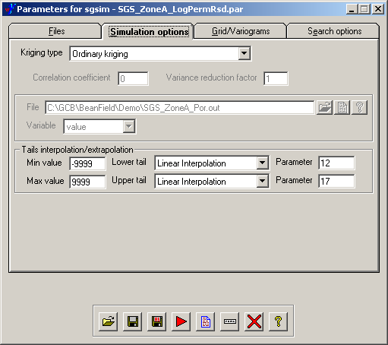

On the Grid/Variograms tab, set the variogram parameters to those for the LogPerm residuals. Again, I am using a spherical variogram model to avoid the instability problems involved with using a Gaussian semivariogram:

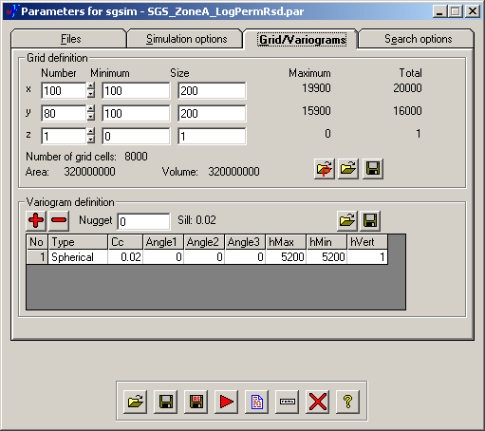

You can leave the search options as they were for the previous simulations. Save the parameters and run sgsim to create the output file with six realizations of the log perm residuals.
My approach at this point was to import the porosity simulation file, SGS_ZoneA_Por.out, into Excel and use this as a starting point for building up a spreadsheet with the desired simulation results. Next to the column of simulated porosity values (48000 of them – 6 realizations on a 100 x 80 grid) I created a column of predicted log perms, LogPermPrd, based on the regression equation from the ZoneA data: LogPerm = -2.784 + 0.1993*Por. Then I imported the file of 48000 simulated log perm residual values and placed these next to LogPermPrd, then added those two columns together to create a column of simulated logs perms. Then I took 10 to the power LogPerm to create a column of perms. Just for convenience, I kept all the header information in a GSLIB-style layout, changing the number of variables (first number in the second row) to 5 to represent the number of variables in the spreadsheet:

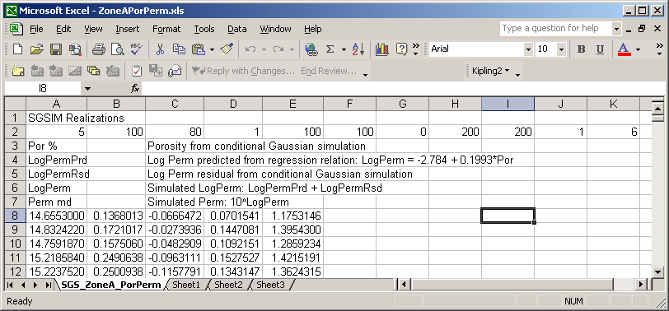

Then I exported this to a tab-delimited text file, ZoneAPorPerm.out. With a bit of editing of the header lines (replacing tabs with spaces – not necessary for the data lines), WinGslib recognized this file as a GSLIB grid file and I was able to use pixelplt to generate PostScript files displaying the results.
Then, under the Tools menu on the main window, I discovered the utility program plotem for putting a number of PostScript files together to create a single display with all six permeability realizations . . .

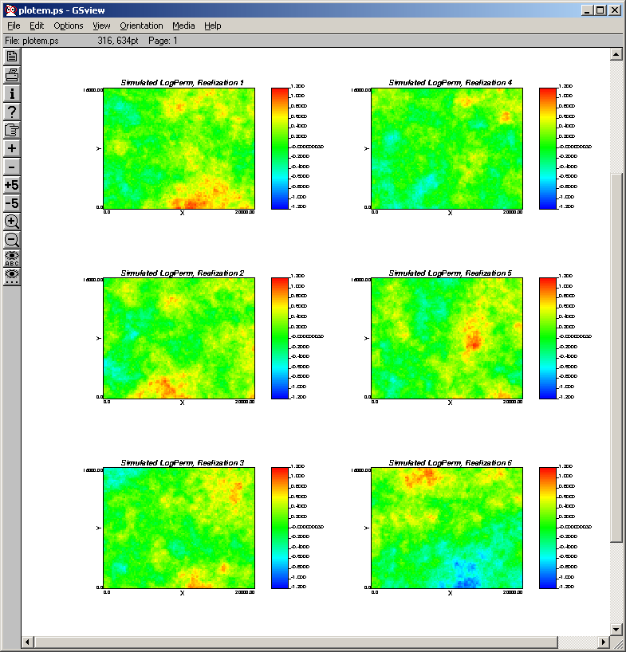

and another with all six porosity realizations:

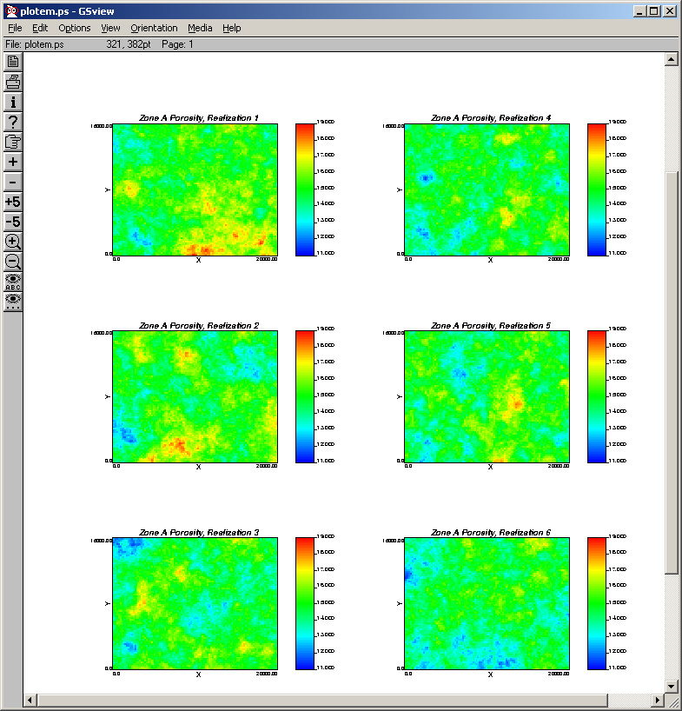

The corresponding pairs of simulations do seem to show fairly strong correlation with each other. I leave it as an exercise to the student to determine whether these realizations actually ended up being properly conditioned on the well data!

